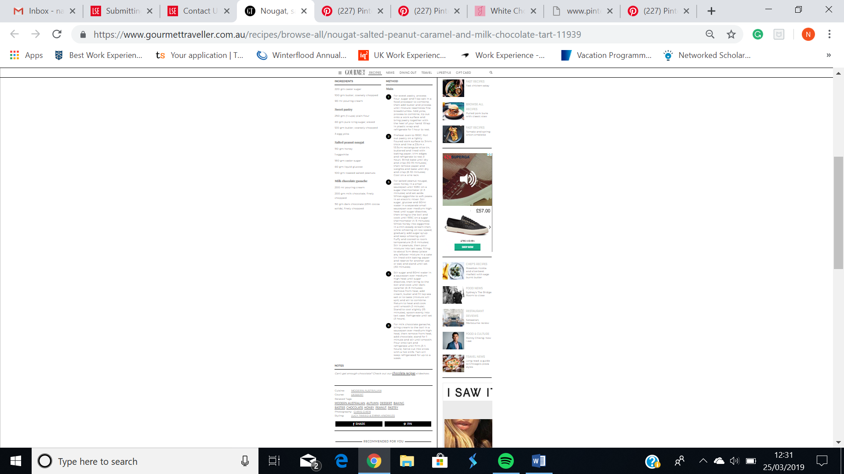Milk Chocolate recipe

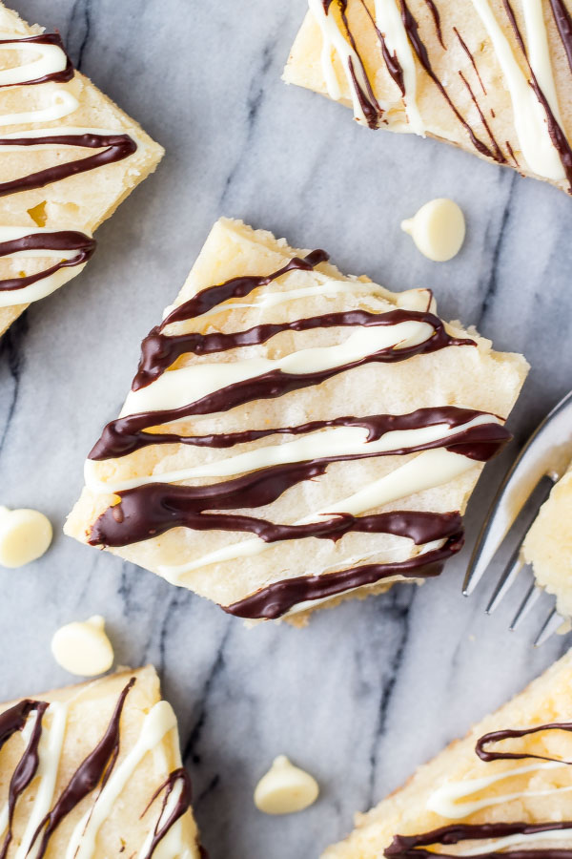White Chocolate Recipe

White Chocolate Brownies

**Prep Time**

15 mins

**Cook Time**

22 mins

**Total Time**

37 mins

Fudgy, gooey white chocolate brownies are heaven in brownie form. These are made in one bowl, and the flavor actually improves after they cool down. If you love white chocolate, these are for you!

Course: Dessert

Servings: 12

Calories: 320 kcal

**Ingredients**

**For the Brownies**

* 2/3 cup unsalted butter
* 6 oz white chocolate , use baking white chocolate not candy melts
* 3/4 cup granulated sugar
* 1 teaspoon vanilla
* 1/4 teaspoon salt
* 2 large eggs , room temperature
* 1 and 1/4 cup all-purpose flour , spooned & leveled

**For the Topping**

* 1/3 cup white chocolate chips
* 1/3 cup semi-sweet chocolate chips , or dark

**Instructions**

1. Preheat the oven to 350F degrees.
2. Line an 8x8 inch baking pan with aluminium foil & spray with non-stick cooking spray and set aside.
3. In a medium sized microwave-safe bowl, melt the butter and white chocolate in short 20 second bursts. Stir after each 20 second burst.
4. After both the butter and white chocolate are melted, cool for 5 minutes.
5. Whisk in the granulated sugar, followed by the vanilla, eggs and salt.
6. Gently fold in the flour.
7. Pour/spoon the mixture into your prepared pan and bake for 20-24 minutes, or until the top is set and the sides are starting to pull away from the pan. An inserted toothpick should come out with a few moist crumbs, or clean.
8. Allow the brownies to cool fully in their pan.
9. To serve, lift the brownies out of the pan using the aluminium foil edges. Carefully peel back the sides of the foil, then cut into 9 or 12 squares.
10. In a small bowl, melt the white chocolate chips in the microwave in short 20 second bursts, stirring between each burst. Drizzle the white chocolate over each square. Repeat the process with the semi-sweet chocolate chips.

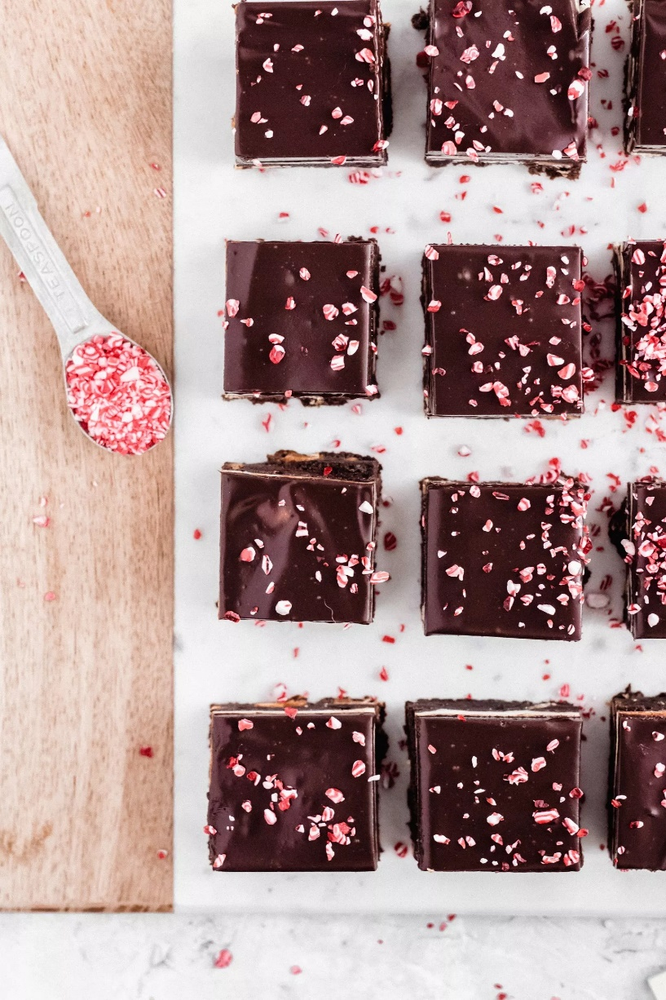

### **INGREDIENTS**

For the Brownies:

* 1/2 cup unsalted butter
* 1 1/4 cup semi-sweet chocolate chips
* 3/4 cup sugar
* 3 large eggs, room temperature
* 1 tsp. pure vanilla extract
* 1 1/2 tsp. espresso powder
* 1/2 cup + 2 Tbsp. flour
* 2 Tbsp. dark cocoa powder
* 1/4 tsp. salt
* 1 cup white chocolate peppermint chunks

For the Cheesecake:

* 8 oz. cream cheese, room temperature
* 1/4 cup sugar
* 1 large egg, room temperature
* 1 tsp. pure vanilla extract

For the Ganache & Topping:

* 1 cup semi-sweet chocolate chips
* 2/3 cup heavy cream
* Crushed candy canes or peppermint sprinkles

### **INSTRUCTIONS**

For the Brownie Batter:

1. Line a 9″ x 9″ baking pan with parchment paper and set aside.
2. In a medium saucepan over medium heat, melt the butter and chocolate chips, stirring constantly until smooth. Remove from heat and pour into large mixing bowl. Let cool for about 10 minutes.
3. Add granulated sugar and whisk to combine. Next, add the eggs one at a time, whisking between each addition until smooth. Whisk in vanilla.
4. Use a rubber spatula to gently fold in the flour, cocoa powder, espresso powder and salt until combined. Add peppermint chunks and gently fold until combined. Pour into prepared baking pan and spread into an even layer. Set aside.

For the Cheesecake Layer:

1. Preheat oven to 350F.
2. In the bowl of a standing mixer fitted with the paddle or whisk attachment, beat the cream cheese on high speed for 1 minute, until smooth and creamy. Reduce to medium speed and gradually add the sugar. Add the egg and extract and mix until combined. Use a rubber spatula to scrape down the sides and bottom of the bowl as necessary and mix until smooth.
3. Pour on top of the brownie batter and use a spatula to create an even layer. Bake for 35 minutes, until a toothpick inserted into the middle comes out with just a few crumbs. If the cheesecake layer begins to brown, cover with foil. Remove from oven and place the pan on a wire rack to cool completely.

For the Ganache & Topping:

1. Place chocolate chips in a heat-proof bowl. Set aside.
2. In a small saucepan over medium heat, bring the heavy cream just to a boil. Pour over the chocolate chips and let sit for 5 minutes without stirring.
3. Stir until smooth and let cool for about 15 minutes (it should be room temperature). Pour over the baked cheesecake layer and then add sprinkles. Let stand at room temperature for 30 minutes before placing in refrigerator.
4. Let brownies cool in the refrigerator for 2 hours, then cut into squares and enjoy! I like to let them warm back up to room temperature, but if you’re too impatient they are good cold, too :)

### **INSTRUCTIONS**

For the Brownie Batter:

1. Line a 9″ x 9″ baking pan with parchment paper and set aside.
2. In a medium saucepan over medium heat, melt the butter and chocolate chips, stirring constantly until smooth. Remove from heat and pour into large mixing bowl. Let cool for about 10 minutes.
3. Add granulated sugar and whisk to combine. Next, add the eggs one at a time, whisking between each addition until smooth. Whisk in vanilla.
4. Use a rubber spatula to gently fold in the flour, cocoa powder, espresso powder and salt until combined. Add peppermint chunks and gently fold until combined. Pour into prepared baking pan and spread into an even layer. Set aside.

For the Cheesecake Layer:

1. Preheat oven to 350F.
2. In the bowl of a standing mixer fitted with the paddle or whisk attachment, beat the cream cheese on high speed for 1 minute, until smooth and creamy. Reduce to medium speed and gradually add the sugar. Add the egg and extract and mix until combined. Use a rubber spatula to scrape down the sides and bottom of the bowl as necessary and mix until smooth.
3. Pour on top of the brownie batter and use a spatula to create an even layer. Bake for 35 minutes, until a toothpick inserted into the middle comes out with just a few crumbs. If the cheesecake layer begins to brown, cover with foil. Remove from oven and place the pan on a wire rack to cool completely.

For the Ganache & Topping:

1. Place chocolate chips in a heat-proof bowl. Set aside.
2. In a small saucepan over medium heat, bring the heavy cream just to a boil. Pour over the chocolate chips and let sit for 5 minutes without stirring.
3. Stir until smooth and let cool for about 15 minutes (it should be room temperature). Pour over the baked cheesecake layer and then add sprinkles. Let stand at room temperature for 30 minutes before placing in refrigerator.
4. Let brownies cool in the refrigerator for 2 hours, then cut into squares and enjoy! I like to let them warm back up to room temperature, but if you’re too impatient they are good cold, too :

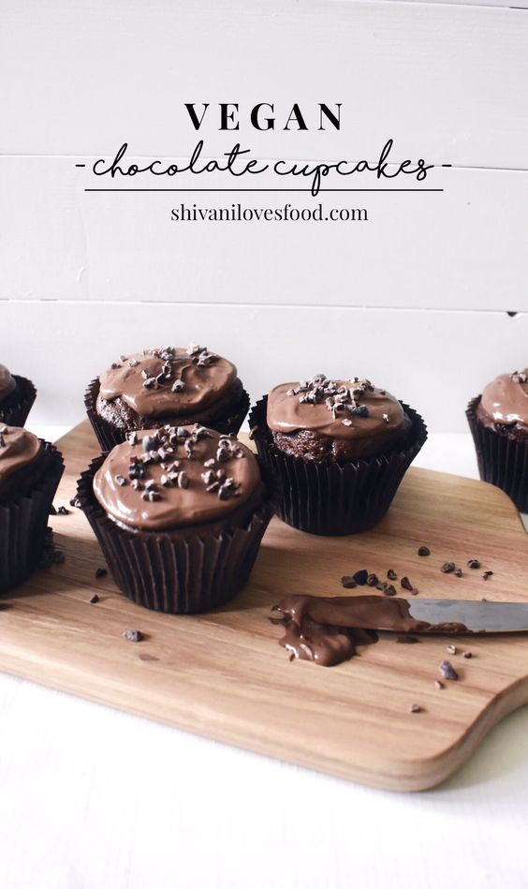

### INGREDIENTS

#### FOR THE CAKES:

* 100 grams Dairy-Free Spread
* 100 grams Caster Sugar
* 40 grams Light Brown Sugar
* 240 millilitres Soy Milk
* 250 grams Plain Flour
* 50 grams Cocoa Powder
* 1 teaspoon Baking Powder
* 1/2 teaspoon Bicarbonate of Soda
* 1/2 teaspoon Salt
* 1 tablespoon Lemon Juice

#### FOR THE GANACHE:

* 50 grams Dark Chocolate roughly chopped
* 75 millilitres Coconut Milk canned, full-fat

#### DECORATION:

* 20 grams Cacao Nibs

### INSTRUCTIONS

#### MAKE THE GANACHE:

* Heat the coconut milk in a small saucepan over low-medium heat until small bubbles form around the edges.
* Take off the heat, and add the chopped dark chocolate.
* Mix until smooth and store in the fridge overnight.

#### MAKE THE CAKES:

* In a large mixing bowl, cream together the dairy-free spread and sugars with a wooden spoon.
* Mix together the dry ingredients in a medium bowl. Alternate adding the dry ingredients and the soy milk in 4-5 increments, mixing well after each addition.
* Add the lemon juice and mix.
* Divide the mixture between 12 muffin cases.
* Bake for 15-20 minutes at 180 degrees until a toothpick inserted comes out clean. Transfer to a wire rack to cool.

#### DECORATION:

* Spread the chilled ganache on the cooled cupcakes with a butter knife. Sprinkle on the cacao nibs and enjoy!

### NOTES

* If you are in a pinch, you can freeze the ganache rather than chilling overnight - it would probably take an hour but keep checking on it!
* A handy tip is to use a ladle to portion out the cake mixture.